Table of Contents

Administration User Guide 2

The Admin Home Screen. 2

The Admin Control Panel 2

The Admin Tool Kit – An Overview. 3

Adding New Tour Dates 3

Adding New Tour Dates – First Screen 3

Adding New Tour Dates – Second Screen 4

Adding New Tour Dates –Third Screen 4

Deleting Tour Dates 5

Deleting Tour Dates – First screen 5

Deleting Tour Dates – Second screen 5

Deleting Tour Dates – Third screen 6

Editing Tour Date Information 6

Editing Tour Date Information – Screen 1 6

Editing Tour Date Information – Screen 2 7

Editing Tour Date Information – Screen 3 7

Editing Tour Date Information – Screen 4 8

Admin Control Panel – Date and Images 8

Using the calendar for dates in forms 9

Uploading Images 9

Final Word 11

# Administration User Guide

**Website home page is under the public folder beginning – ‘public/project/php’.**

**The admin home page is under the admin folder beginning – ‘admin/admin.php’.**

The following is a step by step guide on how to operate the administration tools in the admin side of the website found in the above location.

## The Admin Home Screen.

When you arrive on the admin screen you will be greeted with the following screen:

The above is the login screen. For ease of access the username and password fields inform you of what to enter. As the above screenshot shows, the username is **admin** and the password is also **admin**.

Once you insert these details into the relevant fields you will be granted entry to the admin control panel, which see:

## The Admin Control Panel

The above screen shot is where you will spend most of your time. Think of this as your website tool menu. Anything you want to change to the website content you come here. Always remember to logout when you are finished doing your changes. Incidentally, the logout link will take you back to the username and password login screen.

# The Admin Tool Kit – An Overview.

You will notice that there are links to, ‘ADD’, ‘DELETE’ or ‘EDIT’ changes to particular areas on the website via the control panel. Every area in the website, be it the Tour section or The Photo section for example, gives you an opportunity to add, take away or change content on the website. Think, ‘add’ first, ‘delete’ second and ‘change’ third and this will enable you to learn the flow of the menu system. First let’s begin with, ‘ADDING’ new information to the Tour section of the site.

# Adding New Tour Dates

The first item on the list of the control panel is an opportunity to add new tour dates for the band. The flow of the adding information to the website follows a three-screen process which is;

* First – fill out the new information
* Check to see if the information is correct
* Confirm that you are ready to put the new information on the public website.

## Adding New Tour Dates – First Screen

In the example of adding new band tour information you are faced with this first screen:

The form at the top gives you an opportunity to insert in a new tour date, venue and what country the tour is in. The details below the form let you know the current tour information. Once you have filled in the details in the relevant fields and then click the, ‘add tour date’ button you will be taken to the validation page.

## Adding New Tour Dates – Second Screen

Before we get to the validation screen, the above screenshot lets you see what information we should expect to see confirmed in the next page, which is shown below:

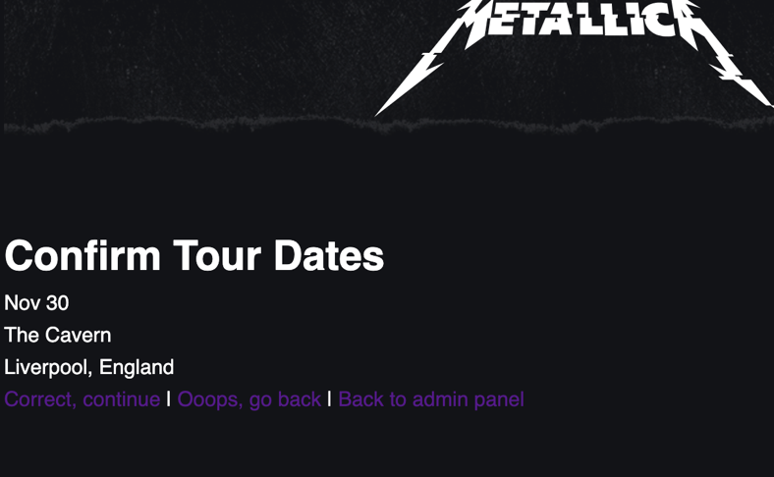

Sure enough, the details we have entered in the form have been echoed in the confirmation screen. This is your opportunity to make sure you are happy to go ahead with this tour entry. If it is in fact not the correct information you have the opportunity to go back and change this as you can see with the three-link option above. On the other hand, if you are happy with the entry made you can click continue and you will be told that the entry has been uploaded to the website. Here the next screen illustrates this.

## Adding New Tour Dates –Third Screen

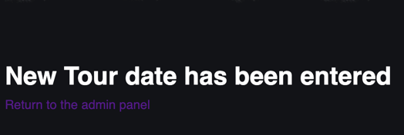

You have entered your first tour date for the band, congratulations! If you go into the tour section on the website, you will see your new entry has been instantly uploaded.

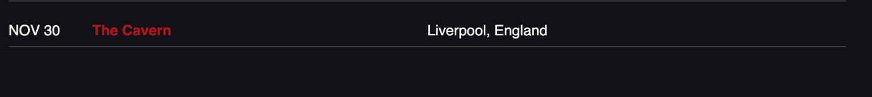

The above tour details are now live on our site. However, as this was just a hypothetical tour date, we cannot have it sitting on our live website. Have no fear though, we can just delete it from the site. The steps below will take you through this process.

# Deleting Tour Dates

Like the adding method, our admin tools again follow a three-step process to delete information from our site:

* First see what needs to be deleted via the list of tour date options
* Choose what needs to be deleted
* Then delete the item from our website

## Deleting Tour Dates – First screen

The above gives the opportunity to find what tour date you want to delete. You scroll down to find our, ‘dummy’ entry:

## Deleting Tour Dates – Second screen

After locating it you click on the entry and it takes you through to the next screen:

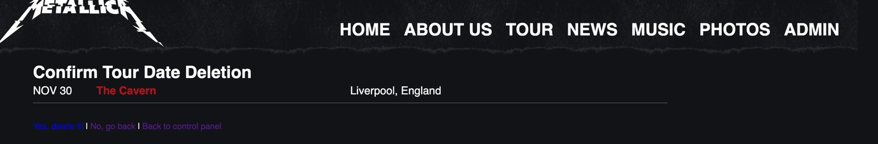

Again, just like the adding tour date tools, this gives you a chance to make sure you have picked the right entry for deletion! If you have made a mistake, just click to go back a step, otherwise click to proceed.

## Deleting Tour Dates – Third screen



Finally, the above screen informs you that the tour item has now been deleted and is no longer on our site. Again, view the tour section on the live website to see that the entry has in fact gone.

# Editing Tour Date Information

The advantage of the admin tools is that they aren’t just binary tools for adding or taking information away, we can also amend the existing information on our site with the edit tools. Here we will explain.

This section differs from that of the add or delete section as the edit section follows a 4-step process:

* Identify what information needs to be changed
* Make the amendments
* Check the new details
* Confirm the changes

## Editing Tour Date Information – Screen 1

Like the adding or deleting section we identify what needs to change:

Once you find what entry needs to be changed you click on that entry. This will take you to this screen:

## Editing Tour Date Information – Screen 2

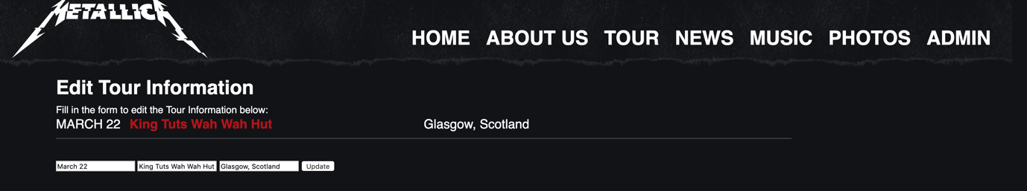

This shows you have isolated the entry that needs to be changed and the form echoes the entry’s details, giving you opportunity to change the item. You notice that the date needs changed from March 22 to April 22, so you put this new information into the necessary fields.

## Editing Tour Date Information – Screen 3

You click update; it takes you to the information check screen:

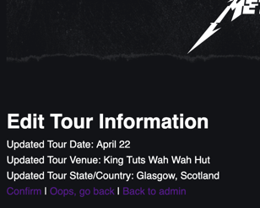

Again, like the Add and Delete Sections, it gives you the opportunity to check to see if the details are entered correctly. Click to go back if you need to change them, click to proceed if are happy with the new details.

## Editing Tour Date Information – Screen 4



And as one last check we see if our new, ‘changed’ data is on live on the site:

And there it is, changed to the new date! Well done.

# Admin Control Panel – Date and Images

The rest of the menu system follows the same procedure for the adding, deleting or editing information on the site. However, there are slight differences in the form execution – some have the date feature which when clicked, gives you the opportunity to enter a date very much the way you would on a calendar. Also, you can insert images to the website via jpeg, png, or gif files. Let’s take a look at these form differences when we consider adding a new news story to the site:

## Using the calendar for dates in forms

Again, like the tour section, it gives a form to insert the new information and a view of the information it will join. However, in the news section there are two distinct differences in the forms – the way dates are entered, and the way images are uploaded. This is the date tool on the form:

Here you can scroll back or forward to get to the right date. Once you find the right date, just click on it and the date will be displayed in a ‘day/month/year’ format in the form. That is fairly self-explanatory. However, the image tool is a little trickier. Which see:

## Uploading Images

You click on the, ‘choose file’ option and a pop-up window will open your files and it is up to you to find where you stored the image you wish to upload to the site. Once you find the file you double click and the form will populate with you image file name instead, ‘of no file chosen’. You then click submit and the admin confirmation screen will show the image you wish to display and give you an opportunity to confirm if you want to proceed or not.

Followed by the image to go on the site:

Once you have confirmed you can check to see if it is up live on the site:

There it is! Furthermore, if you forget to upload an image the site will give a default, ‘no image available’ to remind you to go back and upload an image, which see:

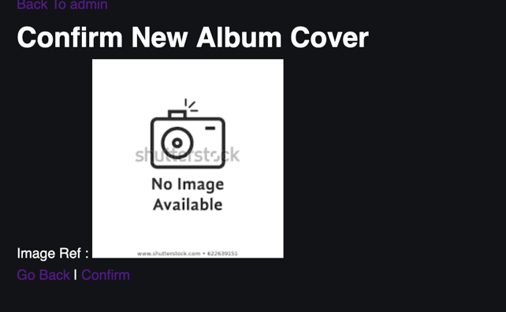

As an adjunct, deleting an image from the website is a similar process to the tour section deletion steps, the only difference is that you click the image you want to delete rather that clicking the text.

## Final Word

That about wraps up the steps on how to make use of the admin tools for the website. Enclosed are further screen shots for you to peruse and to help you in the future. Good Luck!

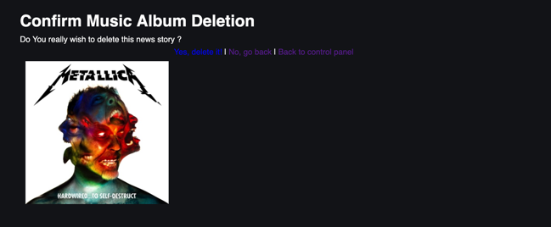

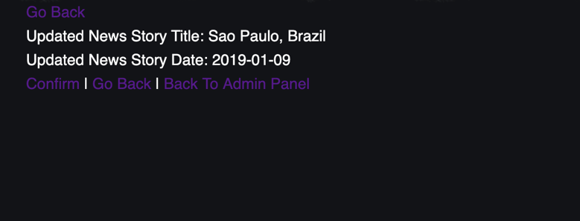

END